**Wake-up call**

**警钟敲响**

(英文部分选自经济学人20220723期财经版块)

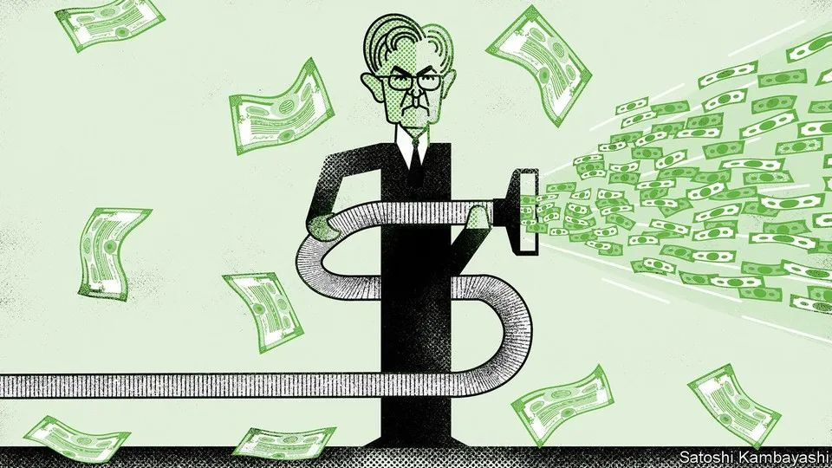

**Wake-up call**

**警钟敲响**

The once-benevolent Fed now looks vengeful for markets

“老好人”美联储目露凶光，市场需保持警惕

When stocks boomed early in the pandemic, an internet meme captured the madness of the moment. On the left-hand side of the image, a worried man exclaims that simply creating money cannot save the economy; on the right, a man representing the Federal Reserve replies “Haha money printer go brrr” while **cranking out** dollars. Joseph Politano, author of Apricitas, an economics newsletter, recently **tweaked** the meme **to** better fit the present situation. On the left, the worried man laments that excessive monetary tightening is increasing the risk of a recession; to the right, the Fed representative retorts “Haha money vacuum go brrr”, while **hoovering up** dollars.

疫情爆发之初，股票暴涨。一张互联网梗图传神地描绘了彼时的疯狂：图左，一个忧心忡忡的人惊呼：“单纯印钱并不能拯救经济！”图右，一个代指美联储的人一边疯狂印钞，一边回答说：“芜湖，印钞机，开动！”。近来，经济类时事通讯Apricitas的作者约瑟夫·波利塔诺（Joseph Politano）把这个梗图稍作改动，使之更符合现下的情况：图左，一个忧心忡忡的人哀叹过度的货币紧缩正在加剧经济衰退的风险；图右，美联储一边用吸尘器疯狂把钞票吸走，一边说道：“芜湖，'吸钱器'，开动！”

注释：

Source: https://www.merriam-webster.com/dictionary/meme

梗图如下：

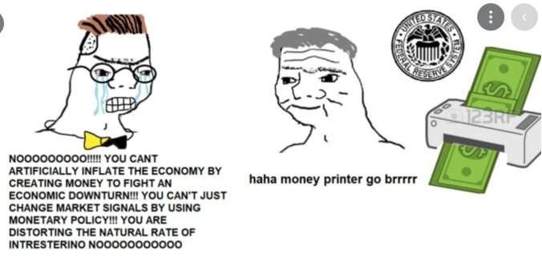

4. 新的网图如下：



In more analytical, if less humorous, terms, another way of framing this shift is to ask whether the Fed put has become a Fed call. The concept of a Fed put dates back to the era of Alan Greenspan, a former chairman of the central bank. **Starting with** the stockmarket crash in 1987 and continuing for more than three decades, the Fed earned a reputation for easing policy, notably by **cutting interest rates**, whenever share prices plunged. To traders this looks a bit like a put option, a basic hedging tool that sets a price floor for investments.

当然，这不过是玩儿梗。用正经、理性一点的方式来解读美联储的这一转变，则是人们不禁要问：“美联储看跌期权”是否已转变为“看涨期权”？美联储看跌期权的概念可以追溯到美联储前主席艾伦·格林斯潘（Alan Greenspan）的时代。1987年股市崩盘后的30多年里，美联储以实施宽松政策而闻名，尤其是每当股价暴跌时的降息救市举措。对于交易员们来说该策略与看跌期权——一种为投资设定价格下限的基本对冲工具颇有几分相似。

延伸阅读：《美国通胀是“恶魔”，被唤醒再难将其封印，该怎么收场？》

Source: https://36kr.com/p/1798341770035590

A Fed call would imply just the opposite: namely, that the **central bank** is **in effect** capping the market (similar to traders who sell call options on their stock holdings). Steve Englander of Standard Chartered, a bank, **laid out** this provocative idea in a recent note to clients: “The Fed may push back against equity market gains until it is comfortable that disinflation is a lock—in other words, [there is] a Fed call.”

美联储看涨期权则正相反，意味着央行实际上为市场价格设定上限（这与交易员卖出所持证券中看涨期权的操作大体相似）。近期，渣打银行（Standard Chartered）的史蒂文•英格兰德（Steve Englander）在给客户的一份简报中提出了这一颇为激进的看法：“在通货膨胀彻底缓解之前，美联储可能会持续压缩股票市场收益。换句话说，美联储看涨期权时代来临了。”

This argument may, **at first glance**, seem rather crude. The Fed has long denied that it targets asset prices in setting monetary policy. Narrowly, its denials are credible. Central bankers look at oodles of data, from real-time growth figures to surveys of inflation expectations. **They cannot afford to be swayed by swings in stocks.** Moreover, share prices reflect many factors **ranging from** the overall economic outlook to corporate idiosyncrasies. Why would the Fed target something that is so volatile and only partially responsive to its actions?

乍看之下，这一观点有些站不住脚。老早之前，美联储便矢口否认其在制定货币政策时有意影响资产价格。不那么细致追究的话，这个辟谣也还算可信。从实时的经济增长数据到调查得出的通货膨胀预期，美联储官员们面对着海量的数据。**他们不能容许自己被股市的波动所左右**。此外，股价反映了许多因素，上到经济整体运行前景，下到不同公司的个体化差异。股价波动频繁，而且美联储针对股市采取的措施也未必招招见效，美联储怎么会非要跟股价过不去呢？

**In a broader sense**, however, the stock market clearly matters to the Fed. Jerome Powell, its current chairman, has repeatedly said that its policies are transmitted to the real economy through financial conditions—a term that refers to the availability and cost of funding for businesses and consumers. Stockmarkets play a crucial role in both shaping and gauging financial conditions. Admittedly, they play a small part in a formal sense: for instance, in one index of financial conditions created by the Fed’s Chicago branch, equity and other asset markets account for just ten of its 105 separate inputs, contrasting with the bigger weights assigned to credit markets. But stocks reflect these other metrics. This is especially true at times of stress. Share prices have fallen this year as indices of financial conditions have tightened, and they have risen when these indices have eased.

然而，**从更广泛的意义上来说**，显然，股票市场对美联储而言意义重大。美联储现任主席杰罗姆·鲍威尔（Jerome Powell）一再表示，美联储的政策通过金融形势（企业和消费者获得融资的可能性和成本）传导至实体经济。股票市场在塑造和衡量金融形势方面都扮演着至关重要的角色。诚然，从形式来看，股市所发挥的作用很小：例如，芝加哥联储编制的金融形势指数中，105个独立输入项里股票和其他资产市场仅占10项，与更高权重的信贷市场形成了鲜明的对比。话虽如此，股票却能反映其他相关指标的情况，在困难时期尤其如此。今年，股价随金融形势指数收紧而下跌，而当指数宽松时，股价又有所上涨。

Concerns about inflation only add to the market’s importance. When share prices rise, consumers, feeling flush, tend to spend more money and companies, feeling confident, tend to hire more workers. A paper in 2019 by Gabriel Chodorow-Reich of Harvard University and colleagues concluded that each dollar of increased stockmarket wealth lifted consumer spending by about three cents annually, while also boosting employment and wages. For a central bank fighting inflation, a large rise in share prices would therefore cut against its efforts.

人们对通胀的担忧更是进一步凸显了股市的重要性。当股价上涨时，纸面上的富贵让消费者倾向于多花钱，公司也信心倍增，因此倾向于雇佣更多的员工。在2019年发表的一篇论文中，哈佛大学的加布里埃尔·乔多洛夫-赖希（Gabriel Chodorow-Reich）及其同事得出结论，股市市值每上涨1美元，就会使年消费总额增加约3美分，并促进就业和工资上涨。因此，对于正努力抗击通胀的美联储来说，股价大幅上涨只会让其事倍功半。

This makes for borderline hypocrisy in Fedspeak. Sober central bankers can explain that they want “appropriate firming of monetary policy and associated tighter financial conditions” to help rectify the supply-and-demand imbalances that are fuelling inflation (as the Fed did indeed say in the minutes of its rate-setting meeting in June). Yet it would be beyond the pale for them to declare that they want “appropriate firming of monetary policy and associated weakness in the stockmarket”—even if their meanings are closely aligned.

这使得美联储的言论近乎虚伪。头脑清醒的官员可能会解释说，他们希望“适当紧缩的货币政策和与之相关联的收紧的金融形势”能够帮助扭转推高通货膨胀的供需不平衡（美联储6月议息会议纪要中也是这么说的）。但是如果他们宣称想要“适当紧缩的货币政策以及相关联的疲软的股市”，那就太过分了，即使两种说法表达的都是一个意思。

In a market crash that impairs the financial system, the Fed put would come back into focus. For now, though, the sell-off has been mostly orderly. A sustained rebound in stocks would be unwelcome for the Fed, and might well **tilt** it **towards** more hawkishness. Investors accustomed to viewing the central bank as a friendly force must instead confront the harsh reality of a Fed call.

如果一场损害金融体系的市场崩盘突然爆发，美联储看跌期权会重新成为焦点。不过就目前而言，抛售也是有序进行的。股市的持续性反弹并不受美联储待见，而且很可能会促使美联储更加鹰派。习惯于将美联储视作“友军”的投资者们将不得不面对美联储看涨期权的现实。

